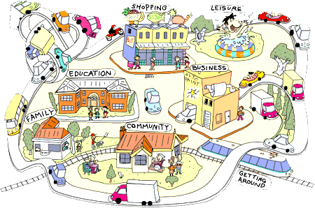

**Adult Learning Disabilities Commissioning**

**Community & Day Activities Market Development**

***Invite to Event***

**Dear all,**

Further to our recent communications with people who use services, family carers and providers; about our plans for developing local community and day activities for adults with learning disabilities, we’re writing to invite you to an event to work together to shape our new local approach.



**Wednesday 28th September 2016**

**10.00am – 13.00pm**

**St. Marys Church, Bramall Lane, S2 4QZ**

***Refreshments will be provided***

This event will be the first of a number of ‘co-production’ meetings planned for October & November 2016. This means people who use services, family carers and service providers will be able to work directly together to help shape what’s needed in the city with a view to implementing a new approach to community and day activities in 2017. We hope you’ll welcome the opportunity to get involved, shape our local approach and take part in further work.

**To book a place, please email:** [**scapbs@sheffield.gov.uk**](mailto:scapbs@sheffield.gov.uk)

***Places will be limited to allow for a good mix of attendees.***

SCC3COLFor general queries please contact Julie Pronesti at:

[julie.pronesti@sheffield.gov.uk](mailto:julie.pronesti@sheffield.gov.uk)