Emergency alert test information
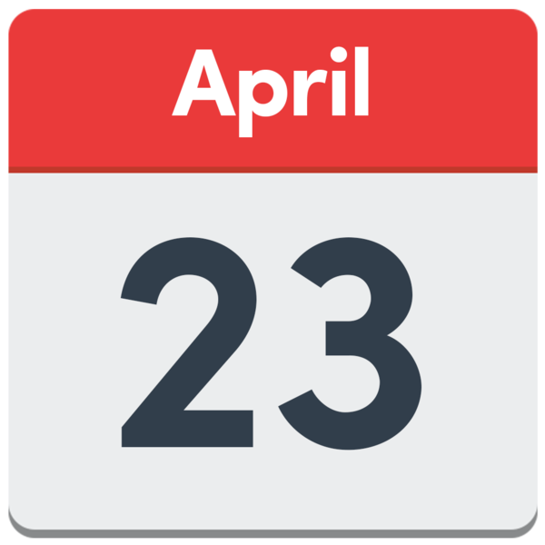
The government are testing an emergency alert on the 23rd April 2023. This alert will
be sent to people’s mobile devices at 3pm.

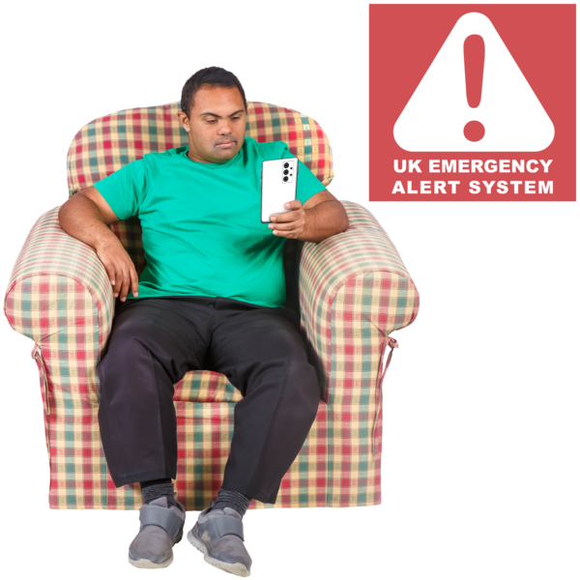
The message will say:
This is a test of emergency alerts, a new
UK government service that will warn you if there is a life-threatening emergency nearby.

This is not a real alert. This alert is a test. You do not need to do anything.

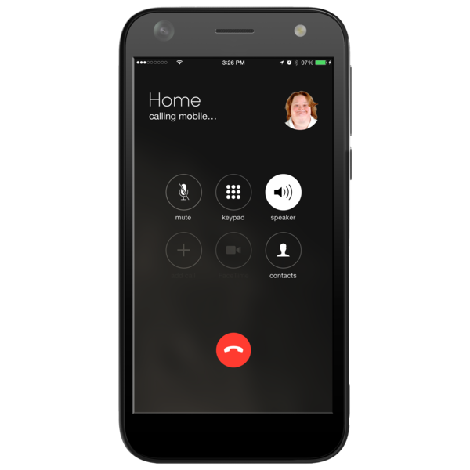

All mobile phones and tablets will get this alert.

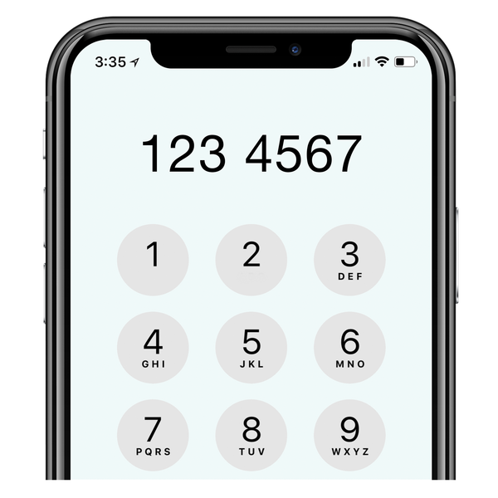
The government does not need to know your phone number to send you this alert. It will go out to every device in the UK.

Your mobile phone or tablet does not have to have Wi-Fi or mobile data to get the text message.

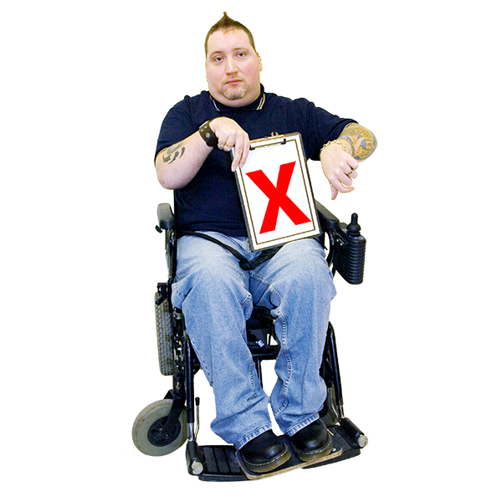

You can choose to turn off emergency alerts if you want to.

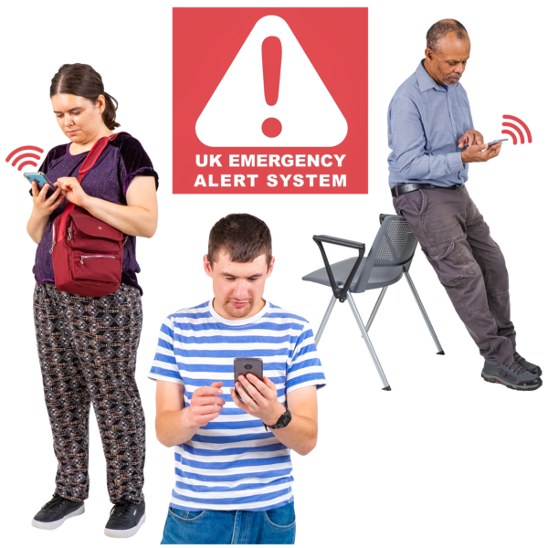
To turn off the alert you need to:
- Find emergency alerts in your settings
- Turn off settings saying severe alerts and extreme alerts.
- If this does not work, or you cannot find where your settings are, you can a helpline for the phone you have, or take your mobile into a phone shop.

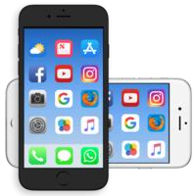
If you know anyone who has a secret mobile phone, please tell them about this. If they turn their phone off or on airplane mode this will also stop any messages coming through.

Easy read guide made by Sheffield voices.

