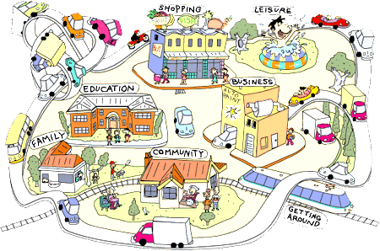

**Adult Learning Disabilities Commissioning**

**Community & Day Activities Market Development**

**Invite to Event**

We would like to invite you to an event.



We want to ask you how services in Sheffield can offer better support in your community to do activities.

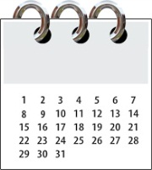

Wednesday 28th September 2016

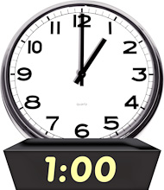

10:00am -13:00pm

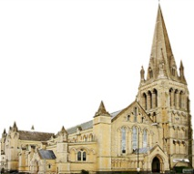

St Mary’s Church, Bramall Lane, Sheffield S2 4QZ



SCC3COL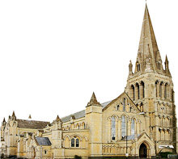Refreshments will be provided

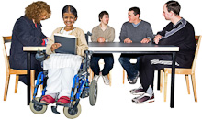We want people who use services, family carers and support providers to work with each other to develop what community and day activities we will have in the city from 2017.

To book a place, please email:

[scapbs@sheffield.gov.uk](mailto:scapbs@sheffield.gov.uk)

**Places will be limited to make sure there is a good mix of people who use services, family carers and service providers.**



For general enquiries, please email Julie Pronesti at:

SCC3COL [julie.pronesti@sheffield.gov.uk](mailto:julie.pronesti@sheffield.gov.uk)