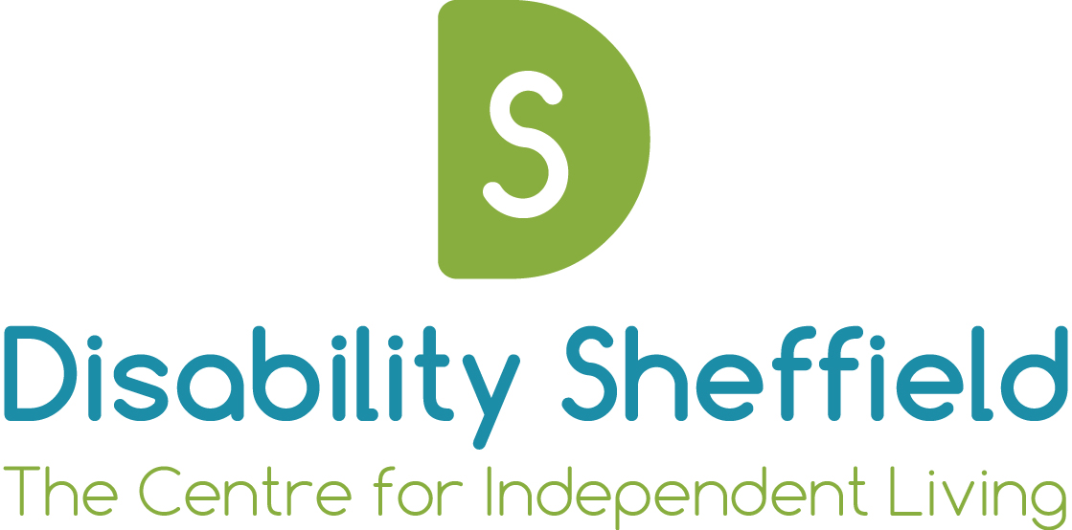

Disability Sheffield

Board of Trustees
Terms of Reference & Members Agreement

Agreed by Disability Sheffield Board

Date:

Chair of Board:

Signed:

Review Date:

About Us

Disability Sheffield is a registered charity and a company limited by guarantee.
People who are elected to our Board become a Trustee of the charity, as well as a Director of the company, and together, we are known as the Board.

As the Board, we have responsibility for what Disability Sheffield does, and how things are done.
The things we need to do are set out in a legal document, called the Memorandum & Articles of Association, and as long as we are honest and trustworthy, and we make sure the charity has enough money to do the things it needs to do, we won’t be held personally liable on the odd occasion things go wrong.

We are not paid, but we can claim out-of-pocket expenses, as long as they are connected with our role and duties as a Board member, and we will make reasonable adjustments to ensure all members of the Board are able to participate equally.

From time-to-time, we will set up sub-committees and working groups to advise the Board on specific matters (such as finance and fundraising), and we employ a Chief Executive whose role is to put Board Members’ plans and decisions into practice, while overseeing the day-to-day running of the charity.

As a User Led Organisation, at least 75% of our Board will have lived experience of disability, and this reflects our commitment to disabled people in Sheffield.

For more information about the role, powers and responsibilities of Board members, please contact our Chief Executive and ask to see our Memorandum & Articles of Association.

The Role

The Board is responsible for maintaining a strategic overview of the work of Disability Sheffield. Particular responsibilities include:

- Making sure the charity’s work stays true to its Memorandum & Articles of Association.
- Making sure the charity complies with all relevant legislation, including employment, company, charity and health & safety law.
- The employment of all staff.
- Making decisions about policies.
- Making decisions about strategic objectives.
- Monitoring and evaluating performance.
- Making sure the assets and finances of the charity are properly managed and accounted for.
- Making sure the charity is accountable to its members, service users and funders.

In addition, Board Members are expected to conduct themselves in accordance with the seven principles of public life created by the Nolan Committee (see Annex below)
Makeup of the Board

Elected Members
The Board is made up of up to 18 elected members. Each member is elected at an AGM to serve for a three-year term. Members may be elected for a second consecutive term, but thereafter may only serve for further consecutive terms by resolution of the Board.

Appointed Members
Casual vacancies, arising through resignation or failure to fill all the vacancies arising at an AGM, may be filled by appointment of the Board until the AGM.

Co-opted Members
The Board has the power to co-opt up to four additional members, who have full attendance rights but who are not registered Directors or Trustees and may not vote at meetings.

Officers
Honorary Officers (Chair, Vice-Chair and Treasurer) are elected by the Board from amongst its members at the first meeting following the AGM, to serve until the first Board meeting following the next AGM.

Timing, quorum & conduct of meetings

Meetings are held quarterly, normally on the third Friday of January, April, July and October, from 1:30pm – 3:00pm.

A quorum for Board meetings is one-third of elected members, as that stands at any one time.

Meetings are chaired by the Chair or, in their absence, the Vice-Chair or, in their absence, such other person who is elected to do so by those present for the duration of the meeting.

Decisions are normally made by consensus. However, when voting is required to reach a decision, this will be on the basis of a simple majority of votes cast by the elected and appointed members present. In the case of an equality of votes, the chair of the meeting is entitled to a second and casting vote, and all Board members should abide by this vote.

Servicing

The Chief Executive, who is also the Company Secretary, is responsible for:
- Preparing agendas in consultation with Honorary Officers.
- Ensuring the preparation and distribution of reports and papers for Board meetings.
- The production of minutes.

Declarations of Interest

Any Board Member who:
(a) Has a personal financial interest in Disability Sheffield’s affairs, or
(b) Stands to benefit from a financial interest in Disability Sheffield’s affairs either personally or through a “connected person”
must declare that interest prior to discussion by the Board on any matter, which could materially affect that interest.

A ‘financial interest’ means an interest in any company or organisation, which is or could be engaged in a financial, business or contractual relationship with Disability Sheffield.

A ‘connected person’ to a Board member means:
- Their spouse, child or step-child.
- A company in which the Board member owns at least 1/5 of the shares.
- A trustee of a trust whose beneficiaries include the Board member or one of those listed in 1 or 2 above.
- A partner in business either with the Board member or one of those listed in 1,2 or 3 above.

In addition, under clause 4 (f) of the Memorandum of Association, they must withdraw from any meeting where their instruction or remuneration, or that of their firm, is being discussed.

Failing to declare an interest in a financial transaction is not only a breach of trust but a criminal offence under the Companies Acts.

Roles & Responsibilities of Board Members

Board members are expected to:
- Attend and contribute to quarterly meetings of the Board, whenever possible.
- Read and where appropriate comment upon reports submitted for the attention of the Board.
- Understand and abide by Disability Sheffield’s policies and codes of practice, including those. on Equal Opportunities and Health & Safety.
- Support all decisions taken by the Board.

In addition, Board members may contribute to Disability Sheffield’s work outside of Board meetings, with the agreement of the Board by:
- Serving on one or more of the Board’s sub-committees or working groups.
- Serving as a Board/link member with one of Disability Sheffield’s projects.
- Participating in planning meetings/workshops.
- Representing Disability Sheffield on outside bodies.
- Conducting appraisals of Officers as appropriate.
- Participating in recruitment panels as required from time to time.
- Attending meetings with funding organisations when requested to do so.

Agreement for Members of the Board

1. I declare that I have read and accept the above terms of reference.

2. (Elected and appointed members only):
Under the terms of the Charities Act 1993, certain persons are disqualified from acting as charity trustees. In this respect I declare that:
- I have never been convicted of an offence involving dishonesty or deception that is not regarded as legally spent;
- I am not an undischarged bankrupt;
- I have never been removed from office as a charity trustee by a Court or the Charity Commissioners;
- I have not been disqualified under the Company Directors Disqualification Act 1986;
- I have never been removed from office under Scottish charity legislation;
- I have never failed to make payments under county court administration orders;
- I have not made compositions with my creditors from which I have not been discharged.

Name:

Signature:

Date:

Annex to Disability Sheffield Board - Terms of Reference
THE SEVEN PRINCIPLES OF PUBLIC LIFE

The seven principles of public life created by the Nolan Committee can be applied to board members of third sector organisations. The following advice is based on the National Council for Voluntary organisations interpretation of Nolan:

Selflessness

Board members have duty to act in the best interests of the organisation as a whole. They should not do so in order to gain financial or other material benefits for themselves, their family, their friends or the organisations they come from or represent.

Integrity

Board members should not place themselves under any financial or other obligations to outside individuals and organisations that might influence them in the performance of their duties.

Objectivity

In carrying out their duties, including making appointments, awarding contracts or recommending individuals for rewards and benefits, board members should make choices on merit.

Accountability

Board members are accountable for their decisions and actions to the public, funders and to service users. They must submit themselves to whatever scrutiny is appropriate to their role.

Openness

Board members should be as open as possible about all decisions and actions they take. They should give reasons for their decisions and restrict information only when the wider interest clearly demands.

Honesty

Board members have a duty to declare any interests relating to their role and to take steps to resolve any conflicts arising in favour of their trustee role

Leadership

Board members should promote and support these principles by leadership and example.

Extract from: Managing without Profit. 1999. Mike Hudson

