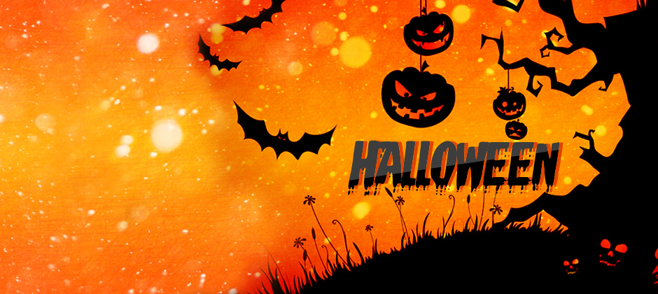

**Sheffield Knight Out Spooky Disco**

**7-11pm 27th October**

**£4 entry includes buffet.**

**Fancy dress optional**

**Transport from end of drive can be arranged**

**Phone Karen 07902097144**

**S W D Sports & Social Club**

[Heeley Bank Road, Sheffield S2 3GL](http://www.bing.com/local?lid=YN1085x250330888&id=YN1085x250330888&q=S+W+D+Sports+%26+Social+Club&name=S+W+D+Sports+%26+Social+Club&cp=53.363208770752%7e-1.46291601657867&ppois=53.363208770752_-1.46291601657867_S+W+D+Sports+%26+Social+Club&FORM=SNAPST)