**Keeping safe- Covid-19**

Here are a few things that you can do to help keep you, your friends, family and Personal Assistants (PAs) safe.

**Ventilation**

Good ventilation can really help to decrease the chances of passing covid (and other bugs) between people in homes, offices and other indoor spaces.

For example, keeping windows, doors, vents open. When travelling in any vehicle open windows as much as possible.

**Social distancing**

Keeping a distance of around 3 feet or 1 metre from others where possible helps to decrease the risk of cross contamination.

**Face masks**

The wearing of face masks is still one of the most important things that we can all do to decrease the risk of spreading covid, or other bugs that are spread through the air.

The risk of airborne bugs including Covid decreases whilst you’re outside.

**Testing**

Anyone working in Social care can access LFT from <https://www.gov.uk/order-coronavirus-rapid-lateral-flow-tests>

If a PA tests positive, discuss with them the best course of action for your needs. Government guidance suggests a person who has a positive COVID-19 result should try to stay at home and avoid contact with other people for 5 days following the day of their positive result. For information please see gov.uk.

For the latest information on testing for Covid-19 visit: <https://www.nhs.uk/conditions/coronavirus-covid-19/testing/get-tested-for-coronavirus/>

|  |  |  |  |
| --- | --- | --- | --- |
| **Author:** | Cinnamon Verge & Blake Williamson | **Version:** | 1.00 |
| **Approved by:** | 2 November 2022 | **Published on:** |  |
| **Approved on:** | Direct Payment Steering Group | **Review due:** | 1 November 2024 |

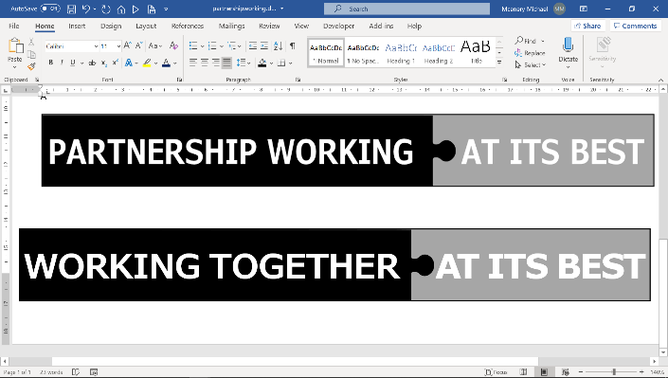H:\Sheffield-CCG-PMS-Blue.emf