Welcome to JG Graves Birthday Party
at Graves Park
Sunday 19th August 10:30am - 4:30pm
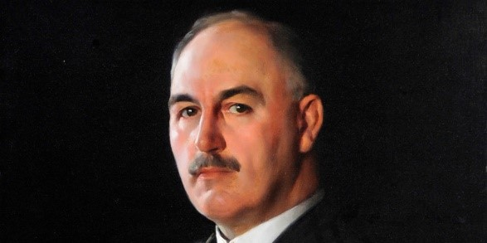

This leaflet gives you a diary of all the events that are happening on the day including their times and location:

ALL DAY EVENTS:
From 10:30 am
Come to the Arena in the Park near the café where there will be 5 Gazebos:
1. Sheffield Guide Dogs will come with different guide dogs for you to see and enjoy;
2. Age UK will tell you all the ways they want to help everyone;
3. Portland Works - a company that helps other companies to improve their business;
4. JG Graves Gazebo 1 - Volunteers will give out a quiz to take into the Farm to complete. Prizes will be awarded to the children taking part;
5. JG Graves Gazebo 2 - Toys will be provided that the children can draw and take home.
You will be able to visit G H Smith Donkeys Entertainment who provide donkeys for the children to ride and also candy floss and Slush.
SRSB (Sheffield Royal Society for the Blind) - this charity is coming to show you how they make such a difference to people’s lives.

Entering via Ashmore Rd or through the Park
Pitch & Putt (the only one in Sheffield!). Come and have a go!

MORNING EVENTS:
In the Arena
10:45 - 11:15 - BARNEY BALONEY - A Magic Show
11.15 - 11.45 - DANCING for the children

AFTERNOON EVENTS:
In the Arena
12:00 - 1:00pm - Fabulous Singers Patricia Lynn and Stevie Moore (Mother and Son)
1:15 – 1:50 - Musician Volunteers who play APPALACHIAN and lots of different songs from around the world.
2:00 – 2:50 - A Story about JG Graves. Come along and listen to how this man helped the city of Sheffield. This is why we are saying HAPPY BIRTHDAY JG GRAVES!
3:00 - 4:00 - Dronfield Genquip Band - They are bringing 25 musicians so what a pleasure it will be to listen to them!

Entering via Ashmore Rd or through the Park
11:00 – 5:00pm - Members of Graves Park Bowling Club will be available to help anyone wishing to try Crown Green Bowling. Refreshments will be available. Why not come along and have a go?
12:00 – 4:00pm - Graves Health & Sports Centre - a member is coming along to teach children how to play TENNIS.
12:00 – 4:30pm - Cricket Pitch - Come along and learn how to CRICKET.

If you need any more information please contact me
Diana Stimely, Chair of Graves Park Forum:
Tel: 07786 635 895
Email: dstimely@btinternet.com

