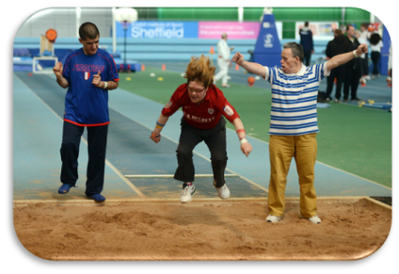
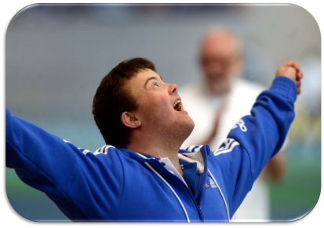
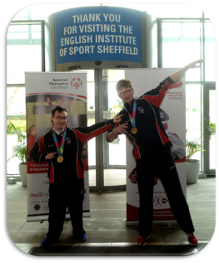
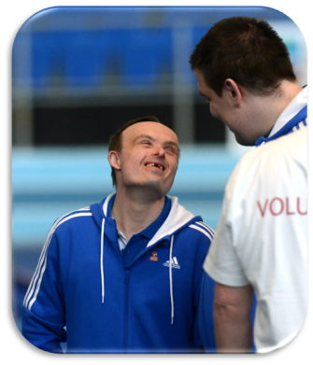
Please fill in and return to Jo Meecham – joanne.meecham@sogb.org.uk by 4pm on Friday 21st July
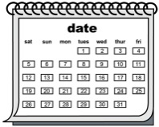 | When | Wednesday 9th August 2017
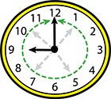 | Time | 12:00pm until 5:00pm  (Registration open from 11.30am, first session starts at 12.10pm)
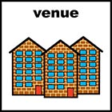 | Where | 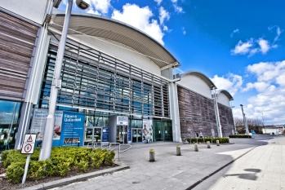  English Institute of Sport - Sheffield  Coleridge Road, Sheffield, S9 5DA
 | Who | People with a learning disability (aged 11 years old and upwards) and their friends, family and supporters.
 | Activities | Athletics, Basketball, Boccia, Cricket, Golf and Tennis  (There will be six 40minute sessions during the day.  Participants will get the experience to try all sports throughout the day. The activities are suitable for all abilities and ages.)
 | Cost | Free

About me: | I am …  (please )  Individual ☐  Group ☐  How many people are in your group?
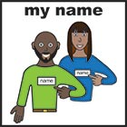 | My / My group’s name is …
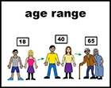 | My / My group’s age is …  (please )  11-16years old ☐  17-25 years old ☐  Over 25 years old ☐
My contact details are …

Email:

Phone number:
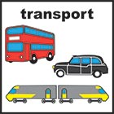 | I will be getting there by …  (please )  Car ☐ Minibus ☐ Taxi ☐  Public Transport (Bus/Tram) ☐
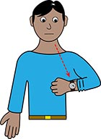  arrival / leaving time | Registration opens at 11.30, the first session starts at 12.10pm.  Please let us know what time you will arrive and what time you need to leave.  I will arrive at:  I will leave at:
Other Information: | 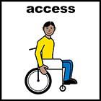  Access  The event is on the ground floor and there are accessible changing facilities. This event is suitable for wheelchair users.  Do you/anyone in your group use a wheelchair?  (please ) Yes ☐ No ☐  Support  Special Olympics GB are able to provide a limited number of volunteers to support during the day.  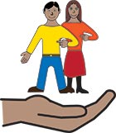  Do you/anyone in your group need any additional support?  Do you/anyone in your group need any support?  (please ) Yes ☐ No ☐  Food and Drink  Special Olympics GB will not be providing lunches and there is no lunch break scheduled.  We will be providing water for people taking part.  There is a café on site however, we advise attendees bring their own lunch/refreshment should they need it.  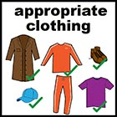  Clothing  Please make sure you/your group wear suitable clothing for the sports activity, including footwear (trainers). No jeans or hard-soled shoes will be allowed in the arena for those taking part in the activity.  Photo/Video Consent  Photos and videos will be taken on the day and will be used by Special Olympics GB after the event for promotion.  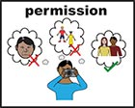  Should you or anyone in your group NOT give consent to have photos and videos taken please ensure you provide us with your name and make yourself known on arrival.  You are permitted to bring your own camera and take your own photographs and videos on site, however, you MUST register your device at the Information desk on arrival.
I confirm I have read and understood the above.

Signature:

Print Name:
For more information … | For more information please contact Laura Davies on …  Email: Laura.davies@sogb.org.uk  Telephone: 020 7375 7624  Mobile: 07535 690 944

