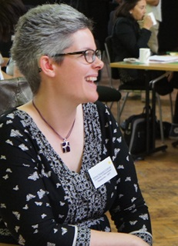

There will be a ‘Deaf with Dementia’ Presentation at the
Doncaster Deaf Community Centre, Milton Walk
On
Thursday 9 November 2017
At
1pm-2pm and 7pm-8pm

Dr Emma Ferguson-Coleman (Deaf) will explain:
- What is dementia?

- Different stories about what it is like to live with dementia

- How to support Deaf people living with dementia

After each presentation, you can ask Emma questions.

Everyone is welcome to come.

