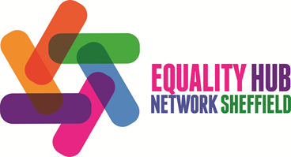
Disability Hub

28 March 2017

Actions and notes

Attendees

- Abduallah Muharib,
- Aletheia Gentle, Sheffield Royal Society for the Blind (SRSB)
- Andrew Crooks, Disability Sheffield
- Craig Williams, Transport 4 All, Disability Hub
- Darren Lee, Free Voice People's Parliament
- Emily Morton, Disability Sheffield
- Emma Daniella Sposato, Women's Equality Party
- Emma Nagouse, Sheffield Feminist Archive
- Enid Bensa, Sheffield 50+
- Fiona Harrison, Partners for Inclusion
- Geraldine O'Connor,
- Grace-Maria Parry, Disability Sheffield
- Hattie Foreman, Sheffield Feminist Archive
- Jake Green, Disability Sheffield
- John Quinn, Disability Hub
- Justin Sheppy, Burton Street Foundation
- Manal Al-Wadhan,
- Martin Brighton, IndyVolCom & HEG
- Neil Simpson, Disability Sheffield
- Paula Ellis, Belong Day Centre
- Paula Quick, Free Voice People's Parliament
- Rachel Sanchez, Sheffield City Council, Equalities and Involvement
- Saskia Peet, Heeley City Farm
- Sharon Brearley, Belong Day Centre
- Steven Storey,
- Sue James, Healthwatch Sheffield
- Tracy White, Free Voice People's Parliament
- Yvonne Allott, Yorkshire Housing

Apologies

- Kath Housley, LGBT Sheffield
- Angela Sampson, SCC, Employment Services
- Debbie Rhebes
- Deborah Sunday, Disability Sheffield
- Ian Proffitt, SYP
- Louise Alford, Sheffield Hallam University
- Rich Allen, Leonard Cheshire Disability
- Suzanne Eusman, Autism Plus
- Wilma Smith, Royal Voluntary Service (RVS)

Actions
- Canvass potential to set up a cross Hub event on transport and invite City Taxis and Licensing Disability Hub (AC)
- Follow up with Healthwatch Sheffield detailed workshop on STP (AC)

Welcome and Introductions (Item 1)

Feedback from previous meeting (Item 2)
- No feedback from the notes listed.

Feedback Equality Hub Network Board 19 January 2017 (Item 3)
- No feedback.

Equality, Sexual Health and Well-Being – Breakout Groups (Item 4)
- This item was included as a response to the annual survey about Sexual Health in Sheffield and its potential to miss the ways in which services can be improved for disabled people.
- The asexuality spectrum was raised as an issue. Is a sexual relationship necessary as part of an “adult relationship” or is it just what wider society expects?
- Sexuality, in relation to people with disabilities, should be raised, addressed and spoken about openly. It shouldn’t be an issue that people should feel ashamed or embarrassed about.
- We should aim for ‘non-judgemental’ tolerance whenever possible.
- The issues about sexual health/sexuality are not generally recognised by institutions.
- Education and openness within family settings can be helpful and supportive.
- Sweden and Denmark seem many years ahead of us in relation to attitudes. Is there anything we could learn from them?
- We should be aiming to be at a position where this topic can be talked about at least as freely as Mental Health is today.
- The value of peer support was raised. People can speak more openly with each other in the right setting whereas it is not always so easy speaking to professionals about such sensitive issues. The overall concept of an “Expert Patients Programme” was raised in relation to this approach.

One group fed back that one of their number is a cross-dresser but finds it difficult being accepted by family or community. As a result they feel very insecure. No place exists where he can continue to practice in a safe, non-judgemental environment.

Licensing and the Equality Duty (Item 5)
The members were brought up to date by AC on activities relating to taxis.

[Comfort break]

Article 50, Brexit and the Impact on Disability Rights (Item 6)
- It was noted that many rights on Disability (as well as Human Rights, Environmental protection etc.) could be subject to threat or change as these are currently subject to EU legislation.
- When we leave the EU will all the precedents already established by the European Courts still be recognised?
- It was generally felt that there could be many effects on people with disabilities. It was requested that the Hub monitors these and feeds back on any changes as/when they occur.

Get Yourself Active, Emily Morton, Disability Sheffield (Item 7)

The Get Yourself Active programme in Sheffield is coordinated by Emily Morton.
- The aim is to increase the number of disabled people involved. Disability Sheffield is helping to recruit anyone who receives ( or knows of anyone who receives ) a direct payment and uses it to take part in any leisure activities who would complete a small survey before, at 6 months and at 12 months about their experiences. Disability Sheffield is also encouraging social workers in the city to include leisure activities as an outcome in people’s support plans.
- Emily said, to coincide with the Special Olympics coming to Sheffield from 7th to 12th August 2017, Disability Sheffield want to celebrate disabled people taking part in leisure activities in the city .We are planning a photographic exhibition in the Winter Gardens during August showcasing leisure and sport activities you enjoy – it could be cycling, swimming, walking, climbing, football, table tennis, snooker, dancing, horse riding – anything which keeps you active, is fun and helps your well-being.
- If you’d like your leisure photos to be included in the exhibition please send them to us along with a brief statement explaining why you enjoy your activity so much by emailing emily.morton@disabilitysheffield.org.uk or phone Emily on 0114 2536747 for more information.
- Entries have to be sent to DS by 15th June 2017.

South Yorkshire and Bassetlaw Sustainability and Transformation Plan (STP) –Sue James, Healthwatch Sheffield (Item 8)

Sue James the Interim Healthwatch Manager presented a briefing on the STP and invited members of the Disability Hub to attend a more detailed follow up session.

Updates (Item 9)

Independent advocacy – Free Voice, Update on Event
- Following this into being.

Transport – Transport4All - Discussion on taxi services
- A purposes was also raised. This issue has also been discussed at Sheffield Transport 4 All (T4A).

Close

Date of next meeting
- 28 June 2017 13:30-16:00 The Circle

Evaluation of the meeting
A few feedback forms were received but not all questions were answered on every form.

- Question 1 - Have you enjoyed the format?
Yes 100%
No
- Questions 2 - How was the length of the event?
Too Long
Too Short
Just Right

- Question 3 - Did you feel able to participate?
Yes 100%
No
- Question 4 - How would you rate information about what is happening in your local area
Very Poor
Poor
Okay
Good
Very Good
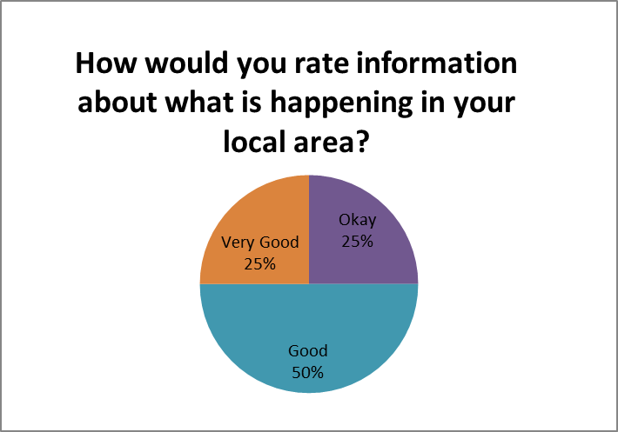
- Questions 5 - How would you rate the discussions at your table?
Very Poor
Poor
Okay
Good
Very Good

- Question 6 -
Yes 100%
No
- Question 7 - Additional comments or suggestions?
Yes 100%
No
- Question 8 - Overall did you find the afternoon to be worthwhile?
Yes 100%
No
- Question 9 - Any other comments or anything you would find useful at the Disability Hub meetings?
Shop staff and disability awareness SCC to set procurement policy example e.g. group 'sparkles'
- Question 10 - Would you like to receive further information or to find out about other Equality Hub related events?
Yes 100%
No

